time=10,a=0,b=0,l=0,e=1,g=0
time=20,a=0,b=1,l=1,e=0,g=0
time=30,a=1,b=0,l=0,e=0,g=1
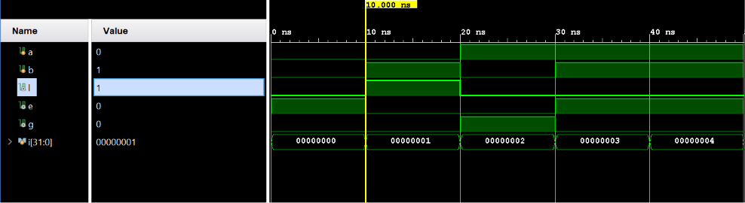
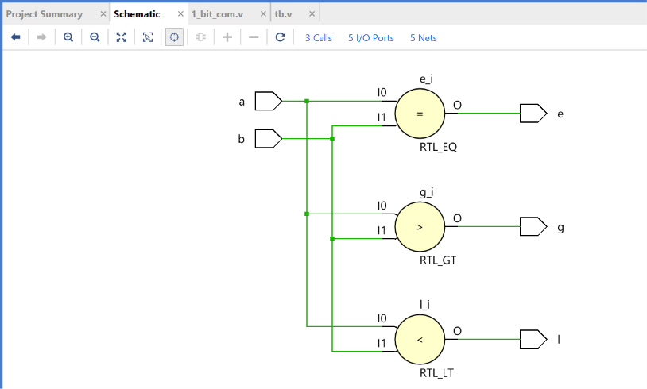
time=40,a=1,b=1,l=0,e=1,g=0

